Mask RCNN based on mass shapes: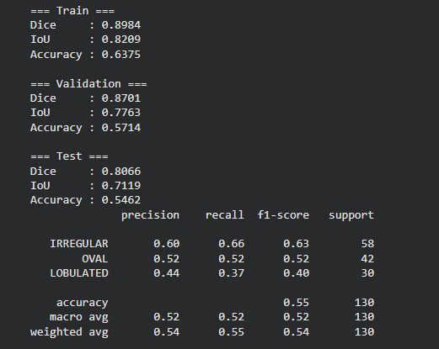

Swin Unet on Mass Shapes:
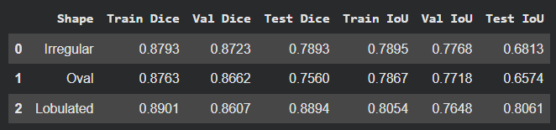

YOLO On Mass Shape:
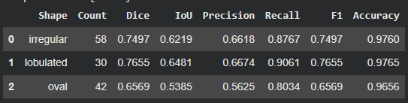

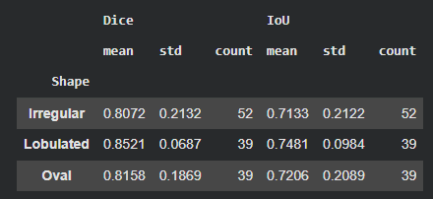

Retina Unet:
